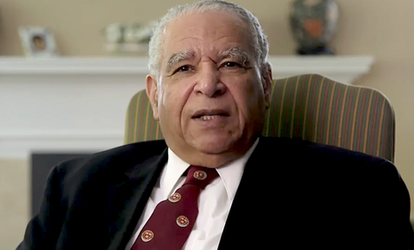
Dr. Albert B. Crum, M.D., DSc,(Hon), M.S.
Benefits of ProImmune Given Before HBOT
ProImmune® has been on the market globally since 2008 and provides certain advantages that can support your hyperbaric treatment projects. This discovery entails using ProImmune’s® Free Form Amino Acid PrecursorsTM (FFAAPTM). This product does not require catabolism before it is utilizable in the synthesis of Glutathione.
As you well understand oxygen therapy increases cellular metabolism and thus produces waste products via oxidative stress. That is where the unity of restoration purpose with Glutathione especially the precursors to Glutathione, known as ProImmune® - Immune Formulation 200® is so helpful with HBOT! The Glutathione remediates the oxidative stress and scavenges the waste products by neutralizing the open valiances in the process that are caused by the heightened metabolism of oxidative stress.
Those open valences are a necessary consequence of oxygen therapy with its increase in metabolism. This is where the efficiency of ProImmune can be very helpful and useful in the restoration process. Incorporating ProImmune® could optimize health to unprecedented levels by incorporating ProImmune® before and after HBOT.
The method of action would simply be to deposit two to three regular scoops of Immune Formulation 200® on the patient’s tongue and almost immediately the Free Form Amino Acid PrecursorsTM enter the bloodstream and into the cellular synthesis of Glutathione. A Scooper is included in each jar. ProImmune is also effective at mitigating heavy metals, gadolinium, glyphosate and microplastics directly inside cells. Nothing foreign to a cell can exist inside the cell when glutathione or oxygen levels are in optimal range.
- Albert B. Crum, M.D., DSc, (Hon), M.S. and Harvard Medical School Graduate
For additional information contact: Mr. Joseph V Cassarino at info@TheBestImmuneSupport.com or via cell at: 845-206-8104.
TheBestImmuneSupport.com
Instagram: Best Immune Support

